***BUSINESS REQUEST/GOALS:***

* Predicting where the new user will book their first travel experience has a great value.
* Such insights or information can help Airbnb share more personalised content with the community, decrease the average time for first booking, understand how a user engages with the service, understand what factors would encourage them to engage more deeply and better forecast demand and many more.

***WHO CARES ABOUT THIS ?***

* Knowing where a new user will book their first travel experience is of great value to Airbnb.
* As a new user getting a personalised treatment is of great value.

***DATA COLLECTION AND WRANGLING:***

* The data is collected from Kaggle. Ref [Data](https://www.kaggle.com/c/airbnb-recruiting-new-user-bookings/data)
* Data mainly comprises demographics information, web session records of the user and some summary statistics.
* Most of the data is clean.
* 'US', 'FR', 'CA', 'GB', 'ES', 'IT', 'PT', 'NL','DE', 'AU', 'NDF' are possible destination countries(classes of target variable)
* Timings are transformed to datetime formats.
* Missing values are transformed to np.NAN.
* Some outliers were observed, like in user age which were replaced by mean age.

***EXPLORATORY DATA ANALYSIS SUMMARY***

Ref script: [EDA](https://github.com/Anandpatil412/DSC/blob/master/CapstoneProject2/DataCleaning/DataCleaning.ipynb)

* We majorly have the following datasets.
  + Train, sessions and countries.
* Quick glance of data

**Train data**

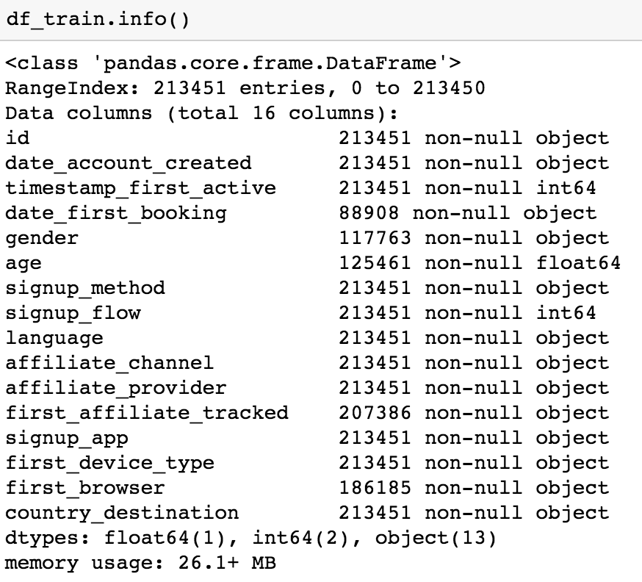

**Session data**

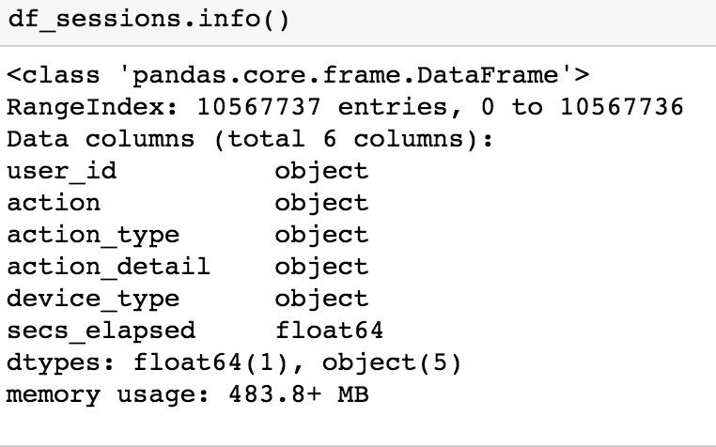

**Countries data**

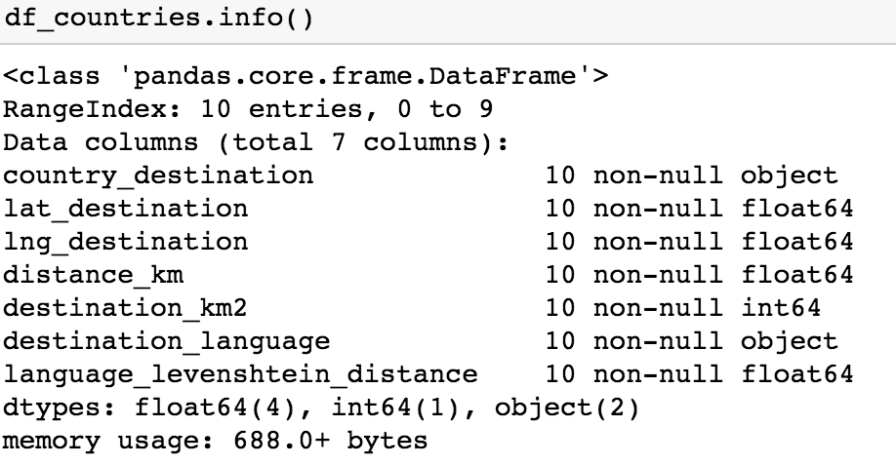

* ***Distribution of destination countries:***

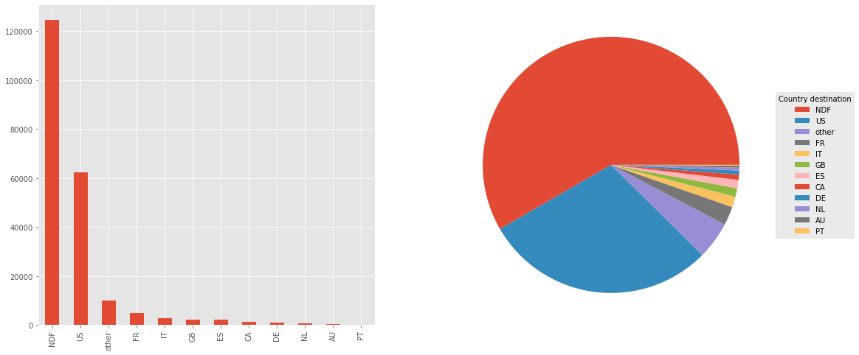

* Most of the users land up doing no bookings(NDF).
* US is the destination country for most of the users, could be because all user data are from people of US which also implies that most users do bookings within the country.
* US and NDF are the most favourable classes making it an imbalance set.
* ***Age group with max users and users who booked:***

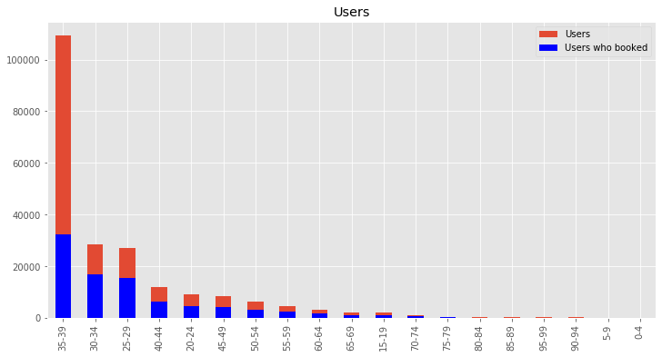

* Most users are from age bucket 35-39.
* There is a lot of variance in count as age bucket varies.
* Age bucket 35-39 has relatively low booking to not booking ratio.
* Users of Age bucket 30-34 and 25-29 has relatively higher booking to Non booking ratio.
* ***Monthly count of first bookings:***

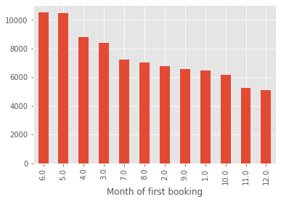

* Mid year(ie May, June) seems to have relatively higher first time bookings.
* Year end has relatively low first bookings.
* ***User session action having highest time elapsed:***

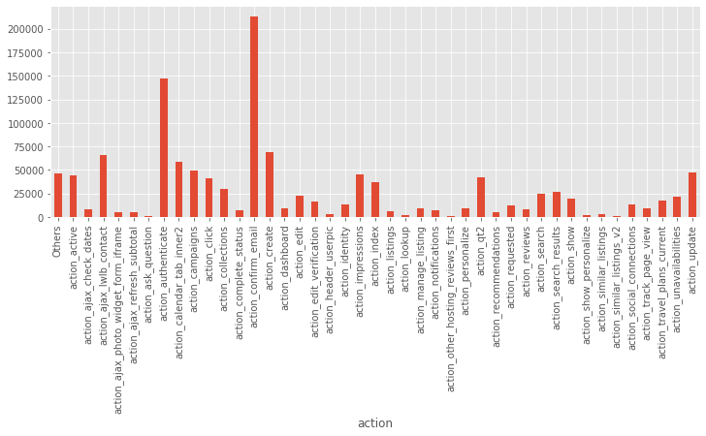

* Action 'confirm_email' and 'authenticate' has the highest mean secsElapsed in a user session.
* ***Language difference and km distance for a US user:***

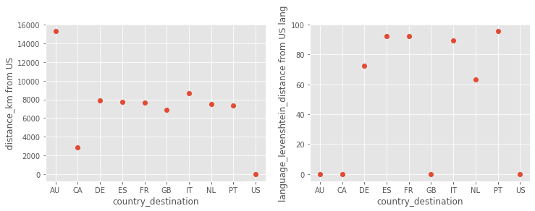

* From plot 1, AU looks farest from the US in km distance.ES, FR, PT have the highest language_levenshtein_distance i.e these languages have the highest difference score from US english.
* ***Demographic information of cities***

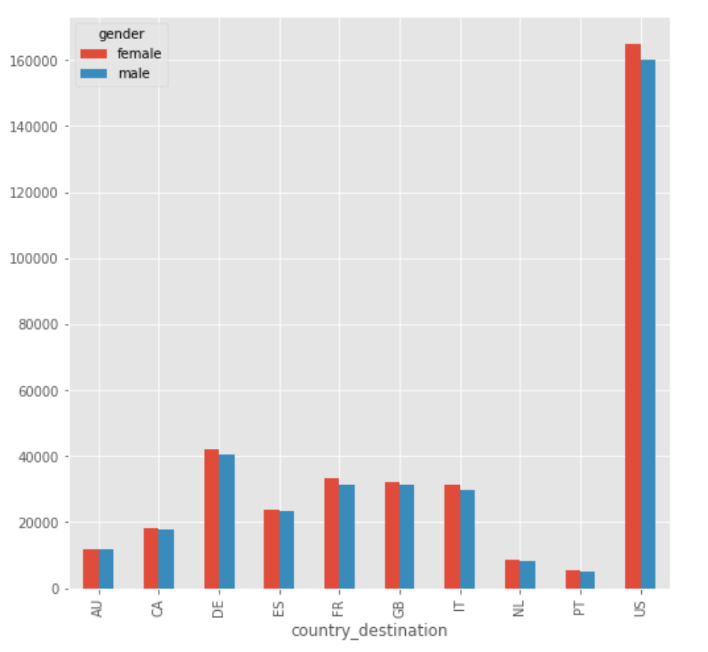

* The US seems to have the highest population, also female population is higher compared to male for all destination countries.
* ***Age bucket wise distribution of destination country***

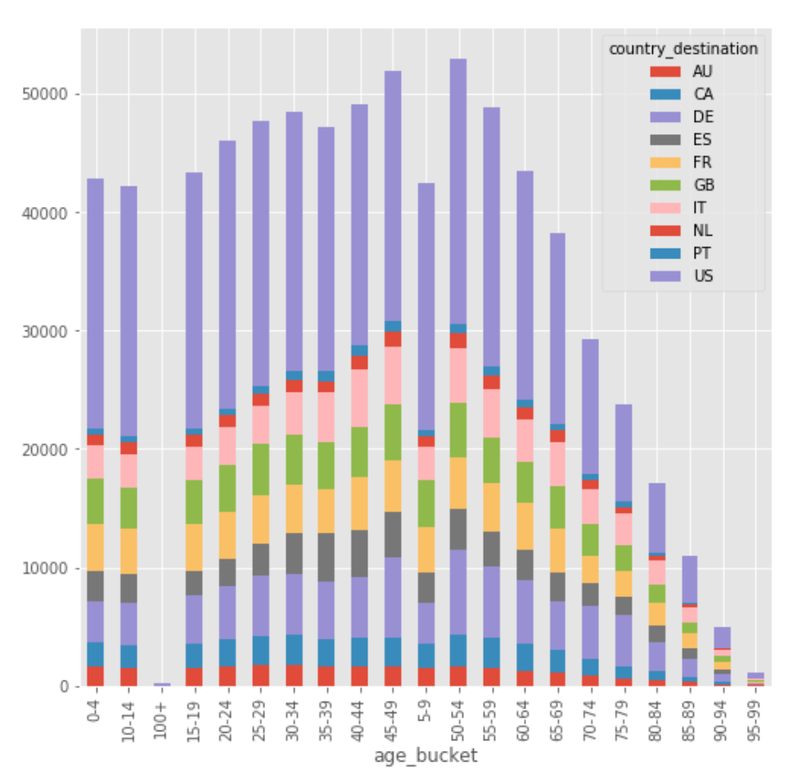

* There is no significant variation in the segments with age buckets.
* ***Highest first bookings and accounts created***

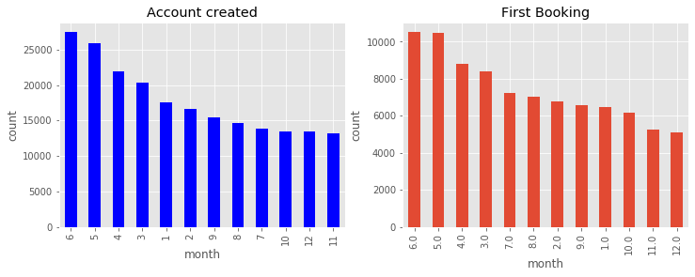

* From the plot Shapes of Account created and first bookings over months are almost same.
* First half of the year has the max accounts created.
* June and May are months of highest first bookings.

***DATA PREPROCESSING AND FEATURE ENGINEERING:***

As a part of data preprocessing and feature engineering following steps were performed.

* Datetime format transformations.
* Extracting important features from datetime like month were added as separate features.
* Less frequent categories considering a threshold were transformed to single categories like ‘Others’.
* Grouping and aggregations.
* Dropping redundant columns.
* Joining eg. Session data was joined with train data.
* Age to Age_group transformation.
* Adding features like user language, age group preferences from the demographics information of the destination countries.